OUYEN P - 12 CollegE
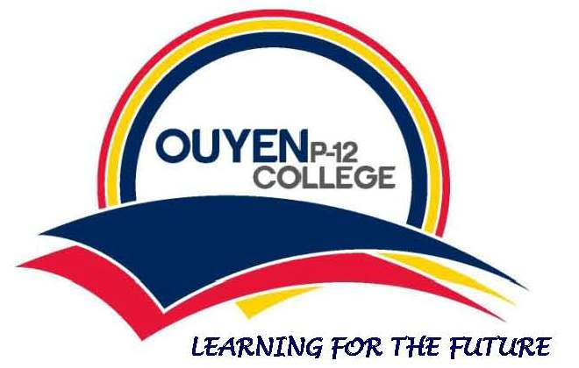

1-35 Fuller Street Ouyen Victoria 3490
03 5092 1182
ouyen.p12@edumail.vic.gov.au

2020 fees for Years 7-10

Student Name ______________________________________________________

Essential education items parents/guardians are required to pay the school to provide for their child:
Curriculum consumables  including C-Tech/Food Technology/Textiles/Woodwork/Art | $170.00
Local excursions, incursions & sport | $18.00
Diary | $12.00
Total | $200.00
*Textbook Levy not applicable this year

Optional additions: computer

Payments are welcome via:
- BPay - contact the school for your details
- EFT - BSB 063732 A/C 10001994 please use student’s name as reference
- Centrepay - arrange through Centrelink
- Cash

